**Exercise 3: Stored Procedures**

**Query for table creation and insertion in Exercise 3:**

CREATE TABLE SavingsAccounts (

AccountID NUMBER PRIMARY KEY,

CustomerID NUMBER,

Balance NUMBER

);

CREATE TABLE Employees (

EmpID NUMBER PRIMARY KEY,

Name VARCHAR2(100),

Department VARCHAR2(50),

Salary NUMBER

);

CREATE TABLE BankAccounts (

AccountID NUMBER PRIMARY KEY,

CustomerID NUMBER,

Balance NUMBER

);

INSERT INTO SavingsAccounts VALUES (101, 1, 1000);

INSERT INTO SavingsAccounts VALUES (102, 2, 2000);

INSERT INTO SavingsAccounts VALUES (103, 3, 3000);

INSERT INTO Employees VALUES (1, 'Alice', 'HR', 50000);

INSERT INTO Employees VALUES (2, 'Bob', 'IT', 60000);

INSERT INTO Employees VALUES (3, 'Charlie', 'IT', 55000);

INSERT INTO BankAccounts VALUES (201, 1, 5000);

INSERT INTO BankAccounts VALUES (202, 1, 3000);

INSERT INTO BankAccounts VALUES (203, 2, 1000);

COMMIT;

**Output:**

**SavingsAccounts Table:**

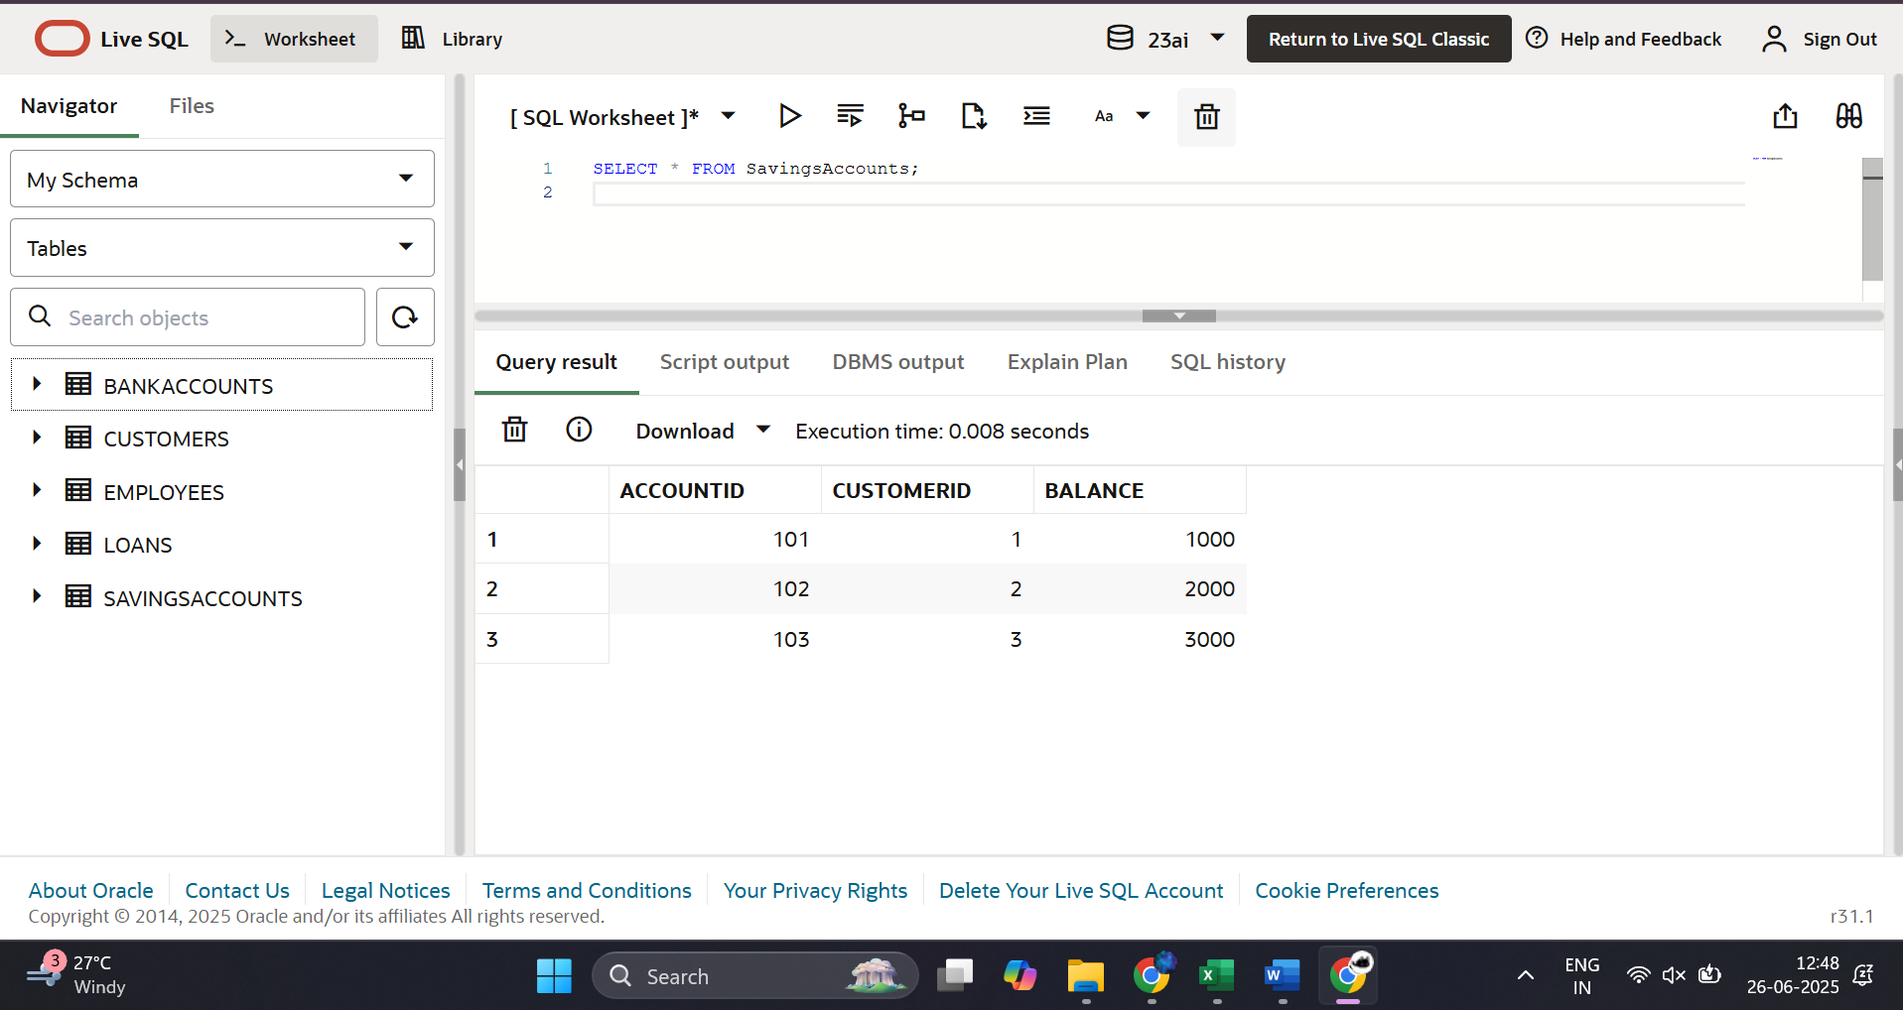

**Employees Table:**

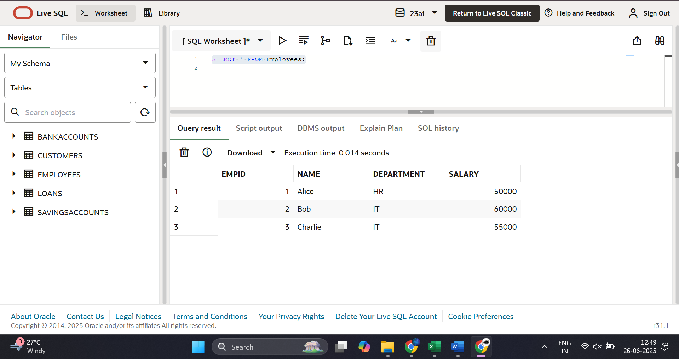

**BankAccounts Table:**

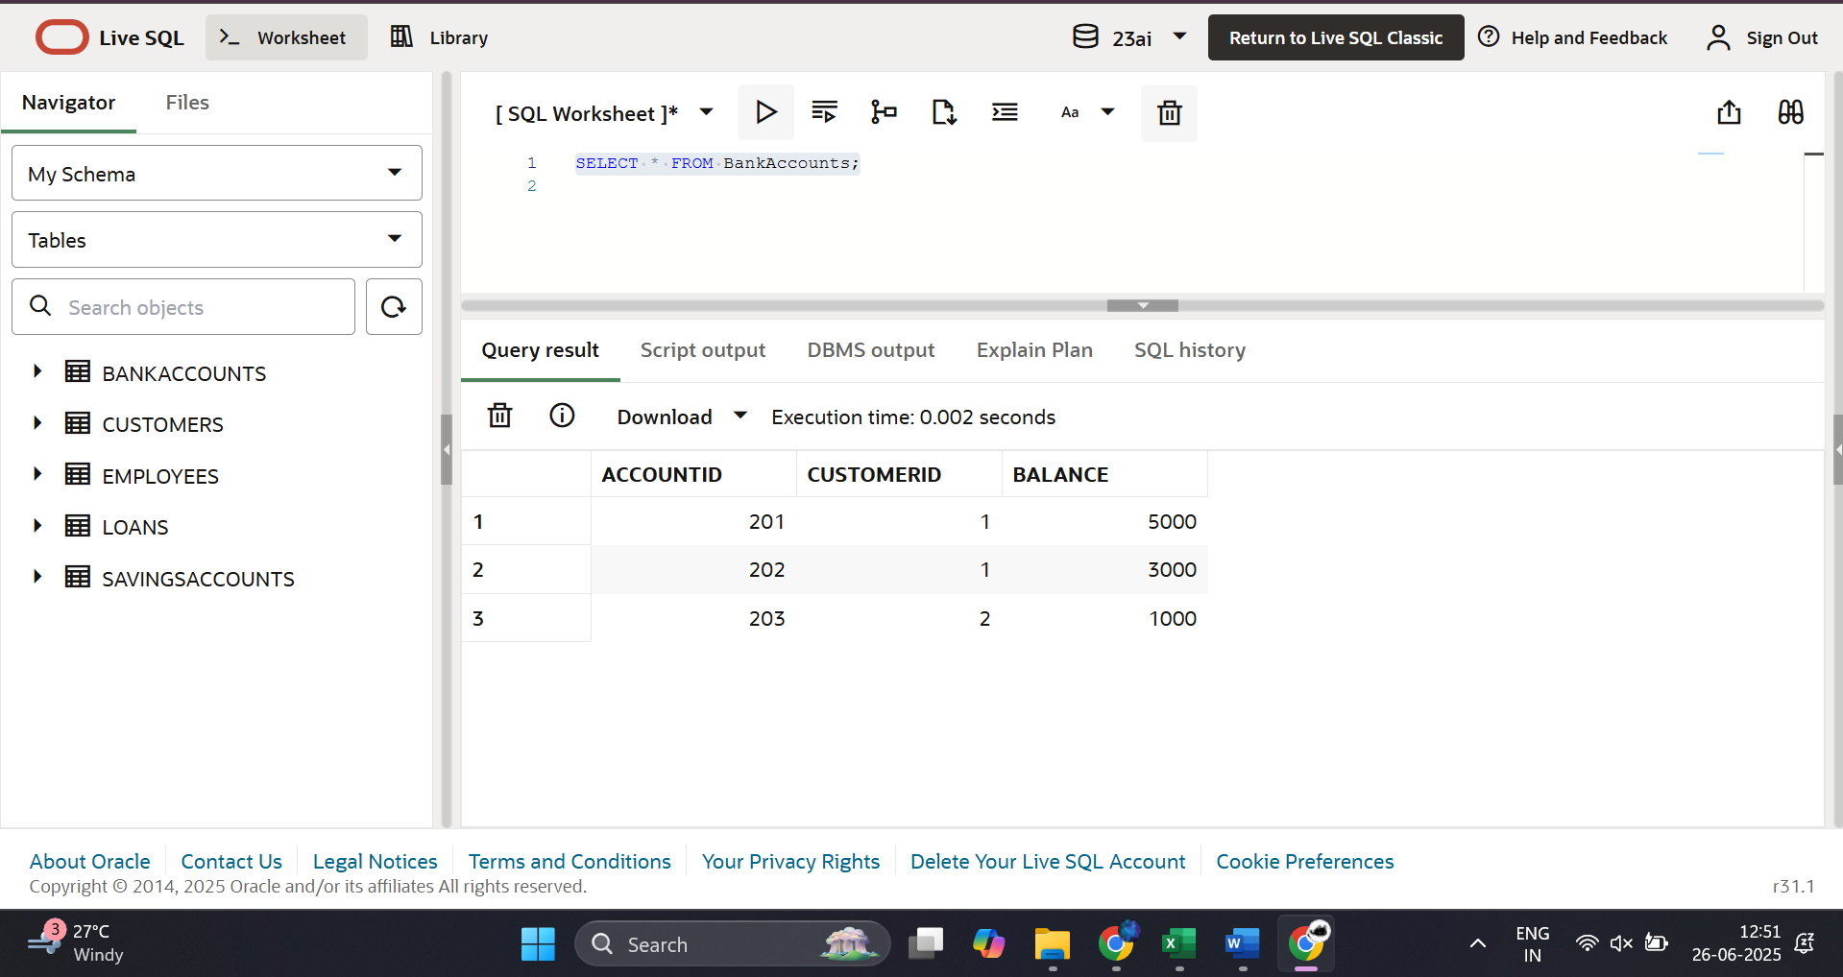

**Scenario1 Query:**

CREATE OR REPLACE PROCEDURE ProcessMonthlyInterest AS

BEGIN

    UPDATE SavingsAccounts

    SET Balance = Balance + (Balance * 0.01);

    DBMS_OUTPUT.PUT_LINE('✅ 1% monthly interest applied to all savings accounts.');

END;

/

BEGIN

    ProcessMonthlyInterest;

END;

/

SELECT * FROM SavingsAccounts;

**Scenario1 Output:**

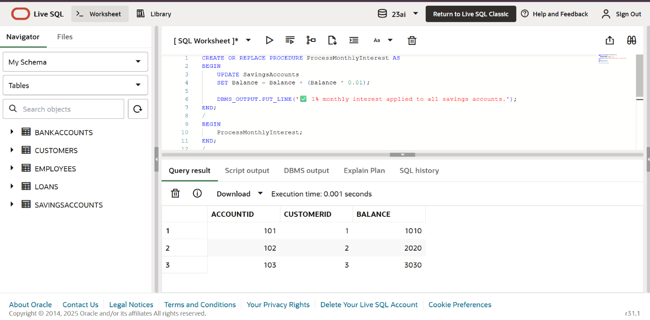

**Scenario2 Query:**

CREATE OR REPLACE PROCEDURE UpdateEmployeeBonus(

    deptName IN VARCHAR2,

    bonusPct IN NUMBER

) AS

BEGIN

    UPDATE Employees

    SET Salary = Salary + (Salary * bonusPct / 100)

    WHERE Department = deptName;

    DBMS_OUTPUT.PUT_LINE(' Bonus of ' || bonusPct || '% applied to department: ' || deptName);

END;

/

BEGIN

    UpdateEmployeeBonus('IT', 10);  -- Apply 10% bonus to IT employees

END;

/

SELECT * FROM Employees;

**Scenario2 Output:**

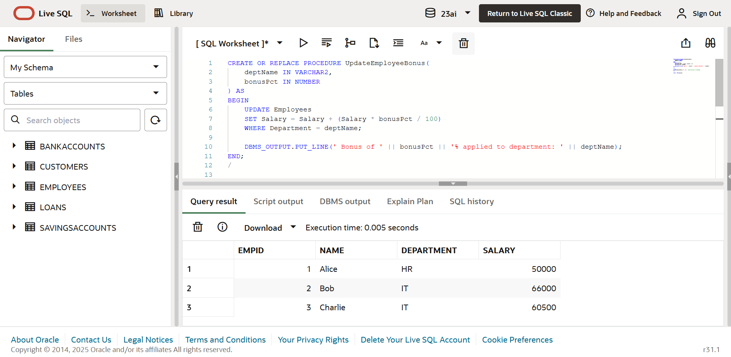

**Scenario3 Query:**

CREATE OR REPLACE PROCEDURE TransferFunds(fromAccount IN NUMBER,  toAccount   IN NUMBER,amount      IN NUMBER) AS  fromBal NUMBER;

BEGIN

    SELECT Balance INTO fromBal FROM BankAccounts WHERE AccountID = fromAccount FOR UPDATE;

    IF fromBal < amount THEN

        RAISE_APPLICATION_ERROR(-20001, 'Insufficient balance in source account.');

    END IF;

    UPDATE BankAccounts

    SET Balance = Balance - amount

    WHERE AccountID = fromAccount;

    UPDATE BankAccounts

    SET Balance = Balance + amount

    WHERE AccountID = toAccount;

    DBMS_OUTPUT.PUT_LINE('✅ Transferred ' || amount || ' from Account ' || fromAccount || ' to Account ' || toAccount);

END;

/

BEGIN

    TransferFunds(201, 202, 1500);  -- Transfer 1500 from 201 to 202

END;

/

SELECT * FROM BankAccounts;

**Scenario3 Output:**

